Temasek Polytechnic

School of Informatics and IT

**Diploma in Information Technology (IT)**

Software Requirement Specifications (SRS)

**Project Particulars**

|  |  |
| --- | --- |
| **Tutor** | Mr Mel Goh |
| **Class** | P01 |
| **Project Title** | Delonix Regia Hotel Management System |

**Project Team’s Particulars**

|  |  |
| --- | --- |
| **Matric Number** | **Student Name** |
| **1500826A** | **Muhammad Faiz Bin Kamaruddin** |
| **1506522J** | **Ang Wei Xiang** |
| **1502868A** | **Thien Yun Kai** |
| **1506657D** | **Darren Teo Wei Wen** |

Revision History

|  |  |  |  |
| --- | --- | --- | --- |
| **Date** | **Version** | **Description** | **Author** |
| <dd/mm/yy> | <x.x> | <details> | <name> |
|  |  |  |  |
|  |  |  |  |
|  |  |  |  |

**Table of Contents**

1. DISTRIBUTION OF WORKLOAD.. 4

2. OVERVIEW OF REQUIREMENTS. 4

2.1 System Functions. 4

2.2 User Characteristics. 4

2.3 General Constraints. 4

2.4 Functional Requirements. 4

2.5 Data Requirements. 4

2.6 User Interface Requirements. 5

2.7 Interface with Other Systems. 5

2.8 Assumptions. 5

3 OPERATIONAL AND QUALITY REQUIREMENTS. 5

3.1 Operating Environment 5

3.2 Development Constraints. 5

3.3 Performance. 5

3.4 Availability. 5

3.5 Security and Access Control Requirements. 6

4 SPECIAL REQUIREMENTS. 6

5 REFERENCES. 6

# 

# **1.** **DISTRIBUTION OF WORKLOAD**

*[Determine which members of the team will be responsible for which areas in the requirement gathering process. Individual’s responsibilities should be clearly spelt out.]*

|  |  |
| --- | --- |
| **Requirement Gathering** | **Members** |
| System Functions, Functional Requirements, Data Requirements, User Interface Design, Interface with Other Systems, Operating Environment, Development Constraints | Muhammad Faiz Bin Kamaruddin |
| System function, functional requirement, user interface Requirements, Development constraint, performance, interface with other systems, operating environment | Ang Wei Xiang |
| System Functions, User Characteristics, General Constraint, Functional Requirements, User Interface Requirements, Availability. | Thein Yun Kai |
| User Interface Design, Security and Access Control Requirements, Availability. | Darren Teo Wei Wen |

# 

# **2.** **OVERVIEW OF REQUIREMENTS**

## **2.1** **System Functions**

*[List and give a brief description of the functions of the systems that are to be implemented.]*

*\*Admins will be able to perform all of the functions.*

* Check duties (Housekeeping staff, Receptionist)
* Housekeeping management (admin)
* Help to create account (admin)
* Booking of hotel Rooms (Customer, receptionist)
* Check availability of Rooms (Receptionist, Customer)
* *Checking out from hotel Rooms (Receptionist)*
* Report on rooms status in the hotel (Receptionist)
* Report on Guests in specific room or all guests (Receptionist)
* Report on Occupancy rate at a time (Receptionist)
* Report on Daily/ Monthly/ Yearly Occupancy rate (Receptionist)
* Report on Housekeeping staff and duties (Receptionist)
* Preview reports before printing. (Receptionist)
* Converting file reports to Excel (Phase 2)
* *Checking into hotel Rooms (Receptionist)*
* *Register account (Customer)*
* *Live Chat (Phase 2)*

## **2.2** **User Characteristics**

*[Describe the characteristics of the users of the systems and the role they play.]*

* End users: Reception Staff at the front counter access parts of the reporting module full access room availability and booking module
* Hotel Manager (Mr. Wang) access to all 3 modules
* System Admin (Tech Guy) access to all 3 modules and user account and creation module
* Housekeeping Staff access to Housekeeping and Staff Management module.

The System Administrator: In charge of the whole hotel’s system which includes the application. He/ She should be experienced and familiar in the technology used by the hotel and is trusted by the hotel to have access to inside information.

The hotel manager: Mr. Wang, the manager of the hotel, who is in charge of the whole operation of the whole hotel. He should be familiar or at least know about the basics of the hotel systems and can do and access everything in the modules.

Receptionist: The front-end desk service for the customers when they require assistance or wish to check in/ out of the hotel. Receptionist also helps to oversee the booking done by the customers. Receptionist are required to be IT savvy so as to navigate the website.

Housekeeping Staff: The staff in charge of the overall cleanliness and looks of the hotel rooms. They will use the system to check their duties and what rooms they are responsible for in their shifts. The staff have basic knowledges of IT.

The customers: The customers of the hotel who are looking to or have booked a room in the hotel. They might or might not be familiar with new technology so they might struggle with the navigation and use of the website. The customers are usually familiar with online booking.

## **2.3** **General Constraints**

*[Highlight any constraints such as dependency on other systems, existing hardware/software platform or technology, restriction due to organization policy or legal requirements.]*

* The system requires Internet.
* The operating system must be able to support browsers to access the website
* The hardware of the system has to be decent enough to complete the processes as taking long period of time causes the session to expire.
* Only adults above the age of 18 should be able to book a hotel room because of organisation policy. Receptionist should check guests for identification before proceeding with booking.
* The browser must keep pop-up blockers turned off when performing the payment process.

## **2.4** **Functional Requirements**

*[Function requirements state what the system should do e.g. the system shall allow library items to be search by Keywords, Author, Title, and Call Number.]*

ID: FR1

Feature: Creation of User Account

Desc: This Function allows the creation of user accounts which can be done by both the customer or the admins.

Scenario: Account creation for normal users

* Given that a User would want to create an account of the hotel website and the user does not have an account.
* When the user registers on the website by providing UserID, Password, Last Name, First Name, Phone Number, Email Address, Mailing Address, Date of Birth, Preferred Payment Method.
* Then the User can complete the registration process.

Scenario: Admin creating account for users

* Given that a User would want to create an account of the hotel website and the user does not have an account.
* The admin helps to registers the account on the website by providing UserID, Password, Last Name, First Name, Phone Number, Email Address, Mailing Address, Date of Birth, Preferred Payment Method and the account type such as staff,admin and etc.
* Then the admin complete the registration process.

Scenario: Confirmed Registration

* Given that the User has already registered with the website
* When the user has not received the confirmation email
  + User can request for resend of confirmation email
* When user has completed confirming the email
* Then the User will be able to login.

Dep: -

ID: FR2

Title: Login

Desc: This function allows the created user to login to the hotel application.

Scenario: Logging in

* When a user who has created an account wishes to login to use the hotel application.
* When the user provides the correct username and password to the system.
* Then the User can login to their account

Dep: FR1

ID: FR3

Title: Forget Password

Desc: This function allows the logged in user to change his/ her password if they forgot their old password.

Scenario: User cannot login to the application.

* When a user gets incorrect username/ password 10 times consecutively.
* When a user who has forgotten his/her password wishes to login to use the hotel application.
* Then the user is unable to login.

Scenario: Forgotten password page

* When the user submits their username/ email to the system after they clicked Forgot Password.
* System asks for email or phone number verification.
  + User can give different country codes if they wish to.
  + User can ask system to resend email.
* User clicks on link given by system to change to a new password.
* Then the user is able to change a new password to login to their account.

Dep: FR1

ID: FR4

Title: Viewing types of room

Desc: This function allows the user to view the types of room (suites) the hotel provides.

Scenario: User wishes to view the type of rooms the hotel has to offer.

* When the customers would like to view the available types of room, the customer are required to select Rooms from the Homepage.
* Then the user is able to see the types of rooms available in the hotel.

Dep: Nil

ID: FR5

Title: Booking of room

Desc: This function allows the receptionist or customers to book the hotel rooms.

Scenario: Receptionist wants to book a room for the customers.

* When the customer provides the receptionist with their form of identification, duration of stay, choice of room, guests in room, payment type, and payment information.
* When the receptionist choose the particular hotel room for the customer and collect payment as well as hand over the room keys.
* Then the receptionist is able to complete booking for the customer.

Scenario: Customers wishes to book the room by themselves.

* Given that the customer wishes to book a room.
* When the Customer selects book a room and enters their desired check-in and check-out date, choice of room, guests in room, payment type, and payment information.
* Then the Customer has completed booking a room.

Scenario: Types of room unavailable

* When the Customer chooses an unavailable room that has been fully booked by other customers.
* Receptionist/ Customer chooses another choice of room and is given the option to split guests into smaller rooms.
* Then the Receptionist/Customers will not book unavailable rooms.

Dep: NIL

ID: FR6

Title: Check availability of room

Desc: This function allows the receptionist, customer and admin to check the room availability before letting them to book.

Scenario: Customer / Receptionist/ wants to check room availability

* When the customer wants to check the room availability, the customer will need to specify the arrival date, departure date, room type and number of adults and children.
* Once the required data are specified
* Then the receptionist, customer and admin will be able to see the list of available rooms.

Dep: Nil

ID: FR7

Title: Viewing types of Facilities

Desc: This function allows Customers to check the different facilities available in the hotel.

Scenario: Customer view the facilities available.

* When the customers would like to view the available facilities, the customer are required to select Facilities from the Homepage.
* Then the Customer will be able to see the available rooms.

Dep: Nil

ID: FR8

Title: Booking of Facilities

Desc: When the receptionist or customer wants to book a hotel facility.

Scenario: Receptionist wants to book a facility for the customers.

* When the customer provides the receptionist with their room number, facility type, date - time, as well as duration.
* When the receptionist enters the customer details and books the facility for them.
* The facility should be booked and cannot be booked again.
* Then the receptionist has completed booking the facility for the customer.

Scenario: Customers wishes to book the facility by themselves.

* When the customer selects book a facility when they are logged in.
* Customer enters their name, room number, facility type, date-time, and duration into the System.
* The facility should be booked by the customer and cannot be booked again.
* Then the customer has completed booking for the facility.

Scenario: When the receptionist selects an unavailable timeslot and facility for the customer.

* When the selected timeslot by user is unavailable as it has been booked by another customer.
* Then the customer will not be able to book on the unavailable timeslot.

Dep: FR2

ID: FR9

Title: Live chat (phase 2)

Desc: When a customer is in need of assistance and wishes to talk to the receptionist live.

Scenario: Customer requires assistance.

* Customer selects Live Chat from the bottom of any page when logged in.
* System puts customer in a queue for live support.
* Receptionist enters the live support window and assists the customers with their problems.
* Then the customer and the receptionist will be able to communicate.

Dep: Nil

ID: FR10

Title: Checking into Rooms

Desc: When the receptionist wants to check in rooms for the customers.

Scenario: Searching the data entry

* Receptionist enter’s customer’s Name, Identification Card Number, Check in Time in the search
* When the system displays the entry, Receptionist selects Check in option for the particular entry.
* Then the room should be checked in.

Scenario: Unable to find entry

* When the Receptionist enter’s customer’s Name, Identification Card Number, Check in Time in the search
* When the system does not displays the entry.
* Then there is no record for user booking to check into the rooms.

Dep: FR1

ID: FR11

Title: Checking out of Rooms

Desc: When the receptionist checks out the customer from the rooms

Scenario: Checking out

* Given the receptionist wants to check out the customers
* Receptionist will enter the customer’s Name, Identification Card Number
* And Remarks
  + When customer purchase anything from the hotel, an amount will be added to the remarks
  + Additional Cost will be incurred
  + Customer selects payment method
  + Then payment for additional cost is completed
* Receptionist will select checkout based on the entry that was searched by the name and identification card number.
* Then the checkout process is completed.

Dep: F10

ID: FR12

Title: Viewing Attractions

Desc: When the customer wishes to view attractions nearby the hotel.

Scenario: Customer view the attractions nearby the hotel.

* When the customers would like to view the attractions, the customer are required to select Attractions from the Homepage.
* Then Customer should then view all the attractions accessible from the hotel..

Dep: Nil

ID: FR13

Title: Manage housekeeping schedule

Desc: This functions will allows the management staff to add/edit/create schedule for the housekeeping staff.

Scenario: Adding new schedule

* A list of form will appear to allow the management staff to enter the required data such as staff ID, start day, time, duties and remarks.
* The staff will click on the “add” button.
* Then the new data has been added to the database.

Scenario: Edit schedule

* The management staff will select the staff ID from the list and a form will appear with the data filled previously. The staff will only edit the required field and save the changes.
* The new data will be changed in the database.

Scenario: Delete schedule

* The management staff will select the staff ID from the list and select the delete button. A confirmation asking to delete the schedule will be prompted.
* The data will then be deleted from the database.

Dep: FR2

ID: FR14

Title: View schedule

Desc: This function allows the housekeeping staff to view their schedule.

Scenario: Viewing housekeeping schedule

* The housekeeping staff will select the “view housekeeping button” and a table will be shown to let them check their duties.
* Then the housekeeping staff will be able to view the schedule

Dep: FR2

ID: FR15

Title: Manage staff schedule

Desc: This function allows management staff to add/edit/create schedule for the staff.

Scenario: Adding new schedule

* A list of form will appear to allow the management staff to enter the required data such as staff ID, start day, time, duties and remarks. Once done, the staff will click on the “add” button.
* Then the new data has been added to the database.

Scenario: Edit schedule

* The management staff will select the staff ID from the list and a form will appear with the data filled previously. The staff will only edit the required field and save the changes.
* The new data will be changed in the database.

Scenario: Delete schedule

* The management staff will select the staff ID from the list and select the delete button. A confirmation asking to delete the schedule will be prompted.
* The data will then be deleted from the database.

Dep: FR2

ID: FR16

Title: View staff schedule

Desc: This function allows the staff such as receptionist to view their schedule.

Scenario:Viewing staff schedule

* The staff will select the “view schedule button” and a table will be shown to let them check their schedules.
* Then the staff will be able to view the schedule.

Dep: FR2

ID: FR17

Title: Report - Room Status

Desc: This function allows the staff (admin, hotel manager, receptionist, housekeeping staff) to view all the rooms in the hotel and the respective room status: Vacant, occupied, taken and has been scheduled for cleaning.

Scenario: View Room Status

* Given that the staff wishes to view the Report of Room Status, The staff will be required to select the Room Status Option from the Report Page.
* The staff will require to set the date and time.
* Then the staff will be able to view the list of room status

Scenario: Editing Room Status Information

* Given that the staff wishes to edit the Report of Room Status, The staff will be required to select the Room Status Option from the Report Page.
* The staff will require to set the date and time.
* Then the staff will be required to select Edit and make the changes. The staff will be required to select save to save the changes.
* Then the staff will be able to edit and save the room status information

Dep: FR2

ID: FR18

Title: Report - Guest Status

Desc: This function allows the staff (admin, hotel manager, receptionist) to view all the guests staying in one particular room in the hotel.

Scenario: View Guest Status

* Given that the staff wishes to view the Report of Guest Status, The staff will be required to select the Guest Status Option from the Report Page.
* The staff will require to set the date and time.
* The staff will require to select the room number
* Then the staff will be able to view the list of Guest Status

Scenario: Editing Guest Status Information

* Given that the staff wishes to edit the Report of Guest Status, The staff will be required to select the Guest Status Option from the Report Page.
* The staff will require to set the date and time.
* The staff will require to select the room number
* Then the staff will be required to select Edit and make the changes. The staff will be required to select “save” to save the changes.
* Then the staff will be able to edit and save the Guest status information

Dep: FR2

ID: FR19

Title: Report - Occupancy Rate at the point of time

Desc: This function allows the management( admin, hotel manager and staff) to view the occupancy rate of the hotels at a certain point of time. However the receptionist is not able to edit the information.

Scenario: View Occupancy Rate at the point of time

* Given that the staff wishes to view the Report of Occupancy Rate at the point of time
* The staff will be required to select the Occupancy Rate at the point of time
* option from the Report Page.
* The staff will require to set the date and time.
* Then the staff will be able to view the report of the Occupancy Rate at the point of time

Scenario: Editing Occupancy Rate at the point of time Information

* Given that the staff wishes to edit the Report of Occupancy Rate at the point of time
* The staff will be required to select the Guest Status Option from the Report Page.
* The staff will require to set the date and time.
* Then the staff will be required to select Edit and make the changes. The staff will be required to select “save” to save the changes.
* Then the staff will be able to edit and save the occupancy rate information

Dep: FR2

ID: FR20

Title: Report - Occupancy Rate

Desc: This function allows the management to view the occupancy rate for a certain period of time.

Scenario: Viewing Occupancy Rate

* The staff will select “Occupancy Rate” button in the reports page and a table will be shown
* Staff will be able to view the occupancy rate for daily,weekly,monthly and yearly.

Dep: FR2

ID: FR21

Title: Report - Housekeeping Duties

Desc: This function allows the management and housekeeping staff to look

Scenario:View Housekeeping Duties.

* The housekeeping staff will select “Housekeeping Duties” button and a table will be shown.
* Housekeeping staff will be able to view their duties.
* Admin and hotel manager would get a different page for the housekeeping duties.
* Admin and hotel manager would be able to view edit duties for the housekeeping staff.

Scenario:Edit Housekeeping Duties

* Admins and hotel manager would be able to select “Edit” in the housekeeping duties page.
* Admins and hotel managers are able to edit the housekeeping duties.

Dep: FR2

## **2.5** **Data Requirements**

*[Data that is stored within the system e.g. Info about books in library, member’s details]*

* Booking of the Rooms require:
  + Last Name,
  + First Name,
  + Identification,
  + Country,
  + Number of Adult and Children in the room,
  + Room Type,
  + Contact details; Phone Number and Email address,
  + Home and Mailing Address ( Street Address/Block or house number/postal code/country),
  + Price,
  + Payment Method(Credit Card Payment/ Upfront Payment(Cash)),
  + Credit Card Details : Credit card number/card holder’s name/expiry date ( if selected credit card payment option)
  + Arrival Date
  + Departure Date
* Checking In/Out:
  + Check in Date & Time
  + Check Out Date & Time
  + Additional Remarks ( Bed Size, Smoking Room)
  + Name
  + IC-Num
  + Check-in Time
  + Remarks
* Housekeeping Schedule
  + Staff ID
  + Staff First Name
  + Staff Last Name
  + Duty Day & Time
  + Location
  + Remarks
  + Maintenance
* Staff Schedule
  + Staff ID
  + Staff First Name
  + Staff Last Name
  + Duty Day & Time
  + Location
  + Remarks
  + Duties
* Account Creation (Staff)
  + Staff ID
  + Password
  + Last Name
  + First Name
  + Contact Details ( Phone Number and Email Address)
  + Home and Mailing Address ( Street Address/Block or house number/postal code/country)
  + Date of Birth
* Account Creation (Customer)
  + User ID
  + Password
  + Last Name
  + First Name
  + Contact Details ( Phone Number and Email Address)
  + Home and Mailing Address ( Street Address/Block or house number/postal code/country)
  + PaymentMethod
  + CreditCardDetails(Credit Card Number.Card Name,Expiry Date)
  + Date of Birth
* Booking Facilities
  + Room Number
  + Phone Number
  + Name
  + Booking Duration
  + Remarks
* Checking Room Availability
  + Type of Room
  + Arrival Date
  + Departure Date
  + Number of Adult and Children in the room
* Check Facilities Availability
  + Type of Facility
  + Date & Time
  + Number of Users
* Reports (Room Status)
  + Date & Time
  + Room Number
  + Type of Room
  + Room Vacancy (Vacant or Occupied)
  + Remarks
* Report (Guest's Status)
  + Date & Time
  + Guest’s Names
  + Guest’s Identification
  + Number of Guests
  + Remarks
* Report (Occupancy Rate at point of time)
  + Date & Time
  + Amount of Customers
  + Remarks
* Report (Occupancy Rate)
  + Date & Time
  + Time Period (daily, weekly, monthly, yearly)
  + Amount of Customers
  + Remarks
* Report (Housekeeping Duties)
  + Date & Time
  + Staff name
  + Staff ID
  + Types of duties
  + *Room Numbers*
  + Remarks
* Live Chat
  + - Staff ID
    - Customer ID
    - Date & Time
    - Chat History

## **2.6** **User Interface Requirements**

*[Describe any user interface diagram or draft screenshot drawn out during the requirements gathering process. You may also describe the navigation mechanism if necessary. ]*

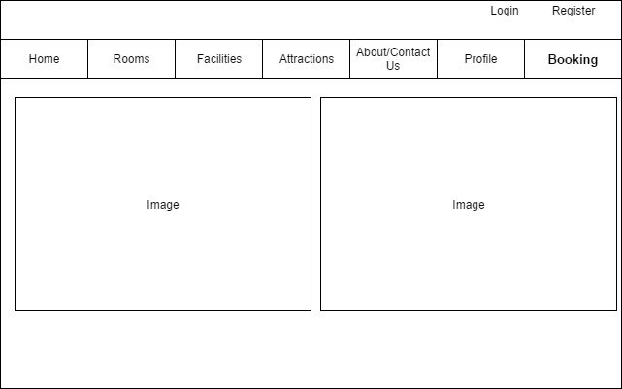

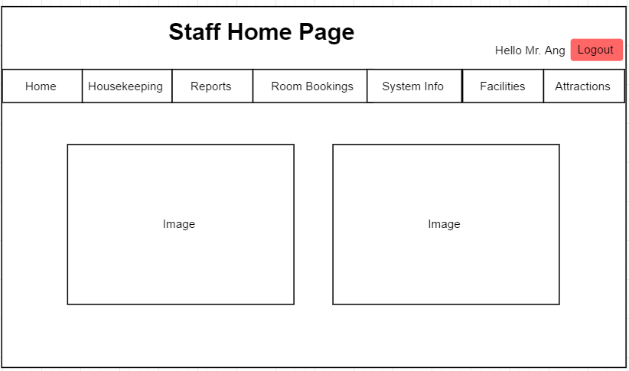

*(Figure 1: Homepage)*

A user of the website should see the Homepage when he/she visits the hotel website. The Homepage displays various features which will allow the users to perform other tasks. The homepage varies for both customers and staff.

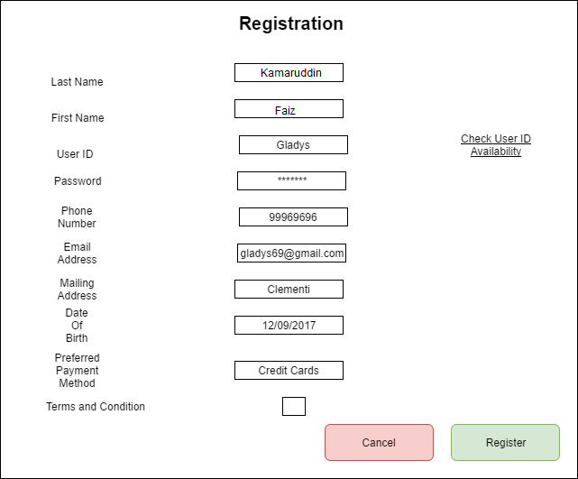

*(Figure 2a: Registration - User)*

Users have the option to register their accounts by selecting register from the homepage/main menu. Its compulsory for the users to have all the data fields input with data and it is compulsory to check the User ID availability by selecting the “check user ID availability” option. To complete the registration process, the user is required to tick the checkbox of the terms and condition and select the “Register” button. If the user would like to cancel the registration, the user can select the cancel button.

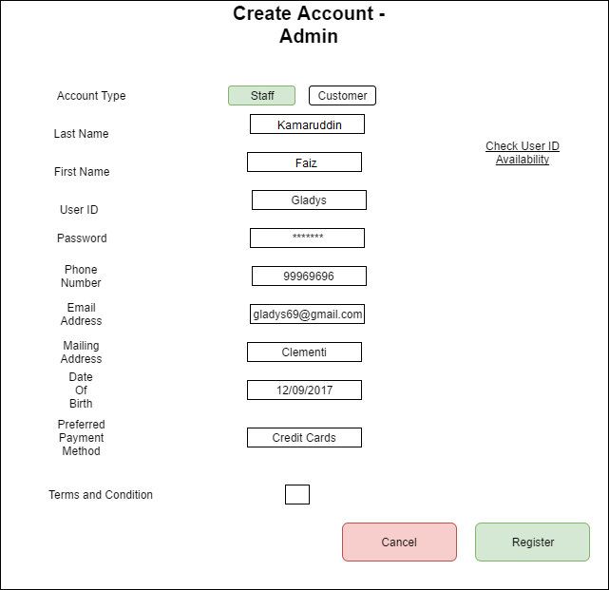

*(Figure 2b: Registration - Admin)*

Admins will be able to register accounts for both staff and customer. This is done by selecting the register option from the menu of the staff options. For the registration process, the admins will be required to input the staff/customers last name, first name, user ID, password, phone number, email address, mailing address, date of birth and preferred payment method. Its compulsory for the admins to have all the data fields input with data and it is compulsory to check the User ID

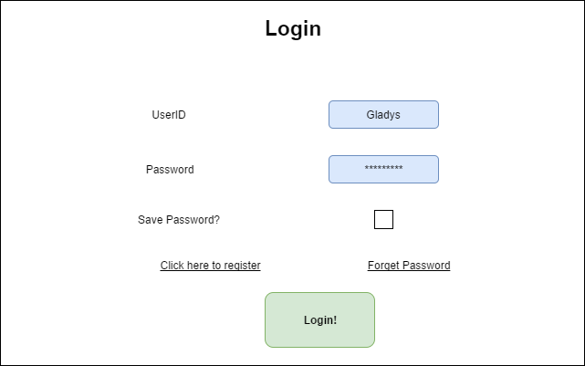

*(Figure 3: Logging in)*

When a user already has an account they are required to login to access other features or to have access to their accounts. The user will need to select Login from the main menu. This will then display the login page. Users will be required to enter their UserID and Password before having access to their accounts. The users will select “Login” button to complete the login process. Users will have the option to save password so that they would not need to input it the next time they try to login. In situations where the users forgot their password, they can select the “forget password” option to reset it or for their password recovery.

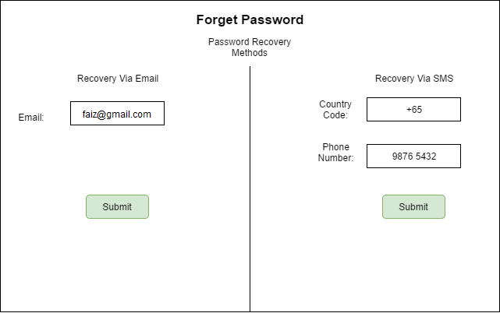

*(Figure 3b: Forget Password)*

Proceeding with the forget password option, users will have 2 methods to recover their password, via email or SMS. For the recovery via Email, users will just have to input their email address tied with their account to complete their recovery process. For the method via SMS, users will be required to input their country code as well as their phone number tied with their account to complete their recovery process.

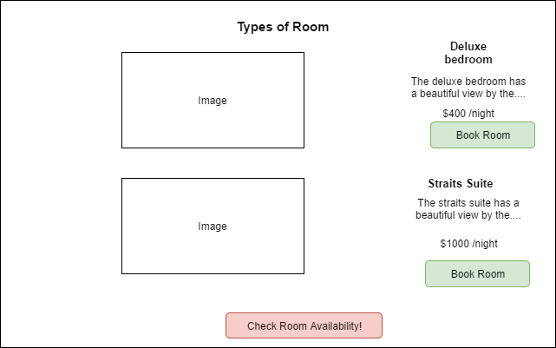

*(Figure 4a: View types of Room)*

Users are able to view the types of rooms the hotel caters, having descriptions of the rooms and features such as selecting to book the rooms or check the availability of rooms.

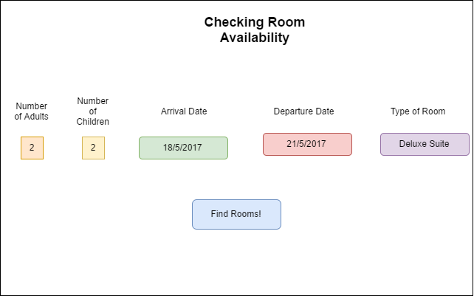

*(Figure 4b: Checking Room Availability)*

Checking Room availability can be accessed by selecting the “view available rooms” option from the homepage/main menu or from the view types of room page. There are a few data fields that are required to be filled up before checking the available rooms. The user will need to input the amount of Adults and Children that will be staying in the room, the arrival and departure date and also the type of room. The user will be required to select “Find Rooms!” to start the search.

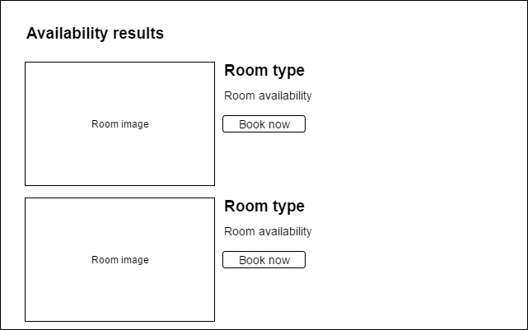

*(Figure 4c: Displaying Room Availability)*

This is the page that will be shown after the user has inputted the amount of Adults and Children that will be staying in the room, the arrival and departure date and also the type of room and click on the “Find Rooms!” button from the checking availability page..

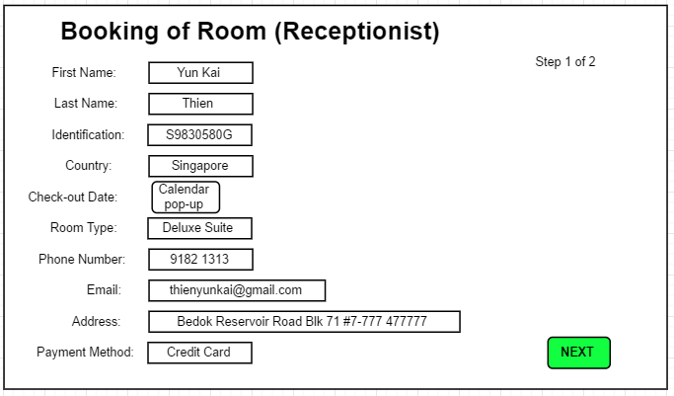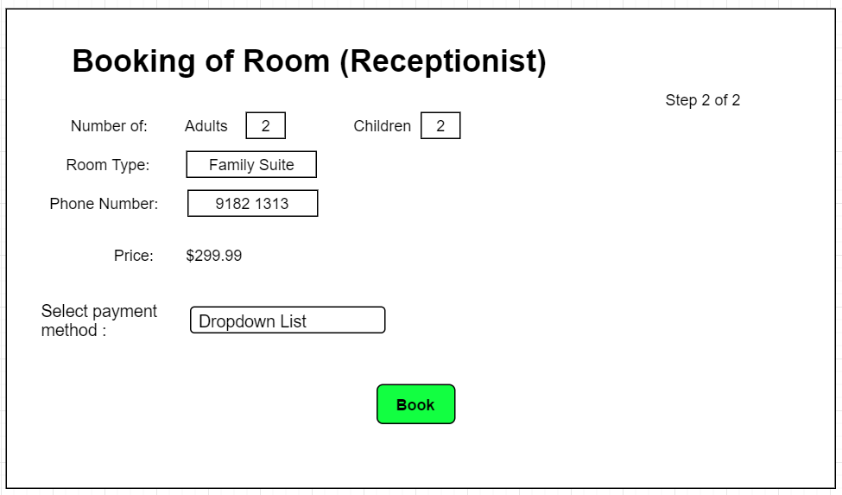

*(Figure 5a: Booking Room - Receptionist)*

The receptionist at the front desk will be able to book a room for a customer who has not booked a room yet and is looking for a room in the hotel. The receptionist can select Booking after he/ she is logged into his respective account to get to the respective pages. The fields above are mandatory and are to be filled by the receptionist. He can get the customer information via his passport or identification card, and the others via communication with the customer. There will be 2 steps or pages to this function, the receptionist will then get the payment information from the customer such as choosing either cash, or credit card (Mastercard, VISA) and enable the machines located at the front desk.

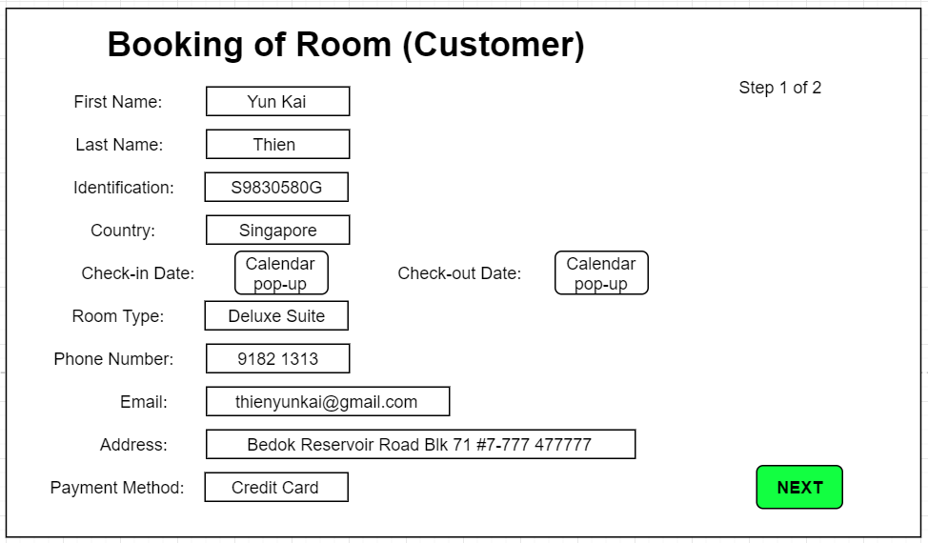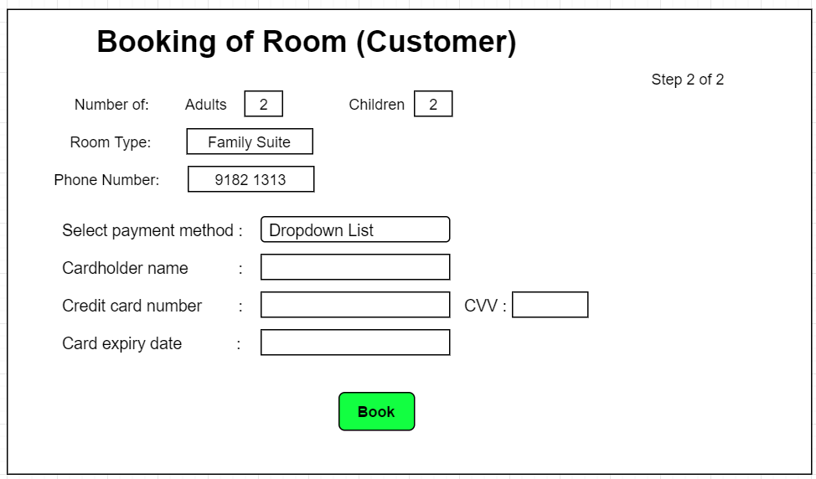

*(Figure 5b: Booking Room - Customer)*

The customer will be able to book a room on the website so that he would have a reserved room before he visits the hotel. The customer can select Booking after he/ she is logged into their respective account to get into the respective pages. The fields above are mandatory and are to be filled by the person who wishes to book. There will be 2 steps or pages to this function. On the second step, the customer will choose their preferred method of payment which is either Mastercard or Visa and enter their credit card details before selecting to book.

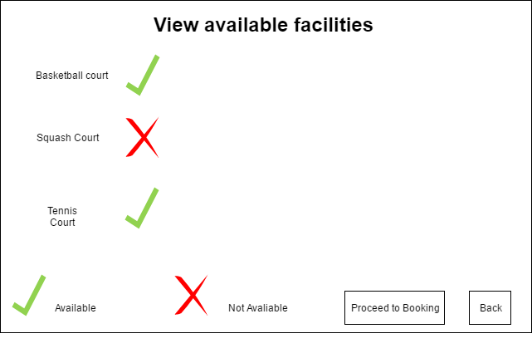*(Figure 6a: Viewing types of Facilities)*

Viewing types of Facilities can be accessed by selecting the “Facilities” option in the homepage/main menu page. It will show the facilities that are available by displaying a tick beside the facility and a cross if the facility is not available. There will be 2 options to either proceed to booking of the cancel which will bring the user back to the homepage.

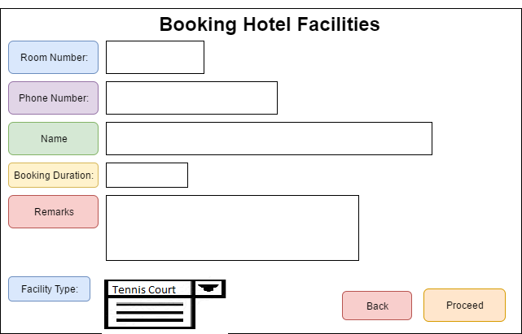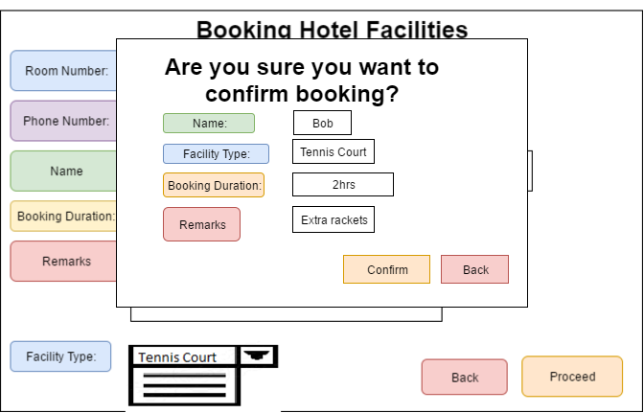*(Figure 6b: Booking Facilities)*

Booking Facilities can be accessed after selecting the “Proceed to Booking” option in the viewing types of facilities page.There are a few data types that need to be entered before booking a facility.The user will need to input room number, phone number, name and the booking duration.The user are allowed to put additional requirements that would be required in the remarks and the user is able to select the type of facility from a drop down list. The user will be required to select “Proceed” to do booking.A confirmation will appear showing the details of the booking of hotel facilities.

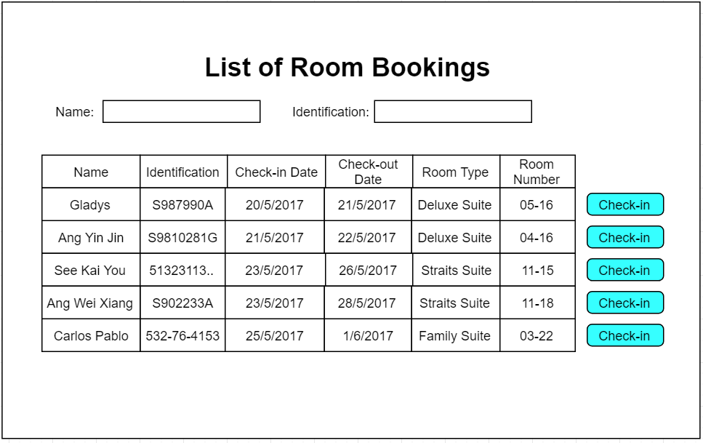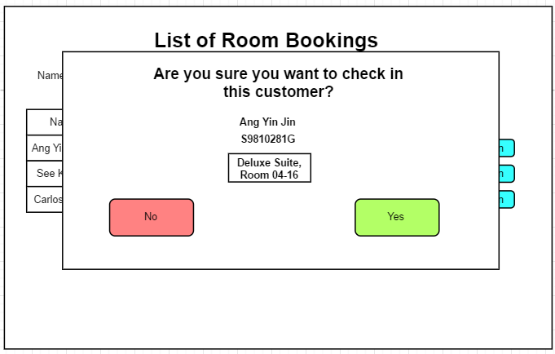

*(Figure 7a: Checking in)*

After the customer has booked a room either via the reception or online, they will be on a database with the list of room bookings and the details of them and the bookings. The receptionist can search their names or identification to narrow down the list to a specific guest. The receptionist will then be able to select the check-in option on the particular guest and check them into the room, after giving them the hotel card. The receptionist will be able to access the page via their home page.

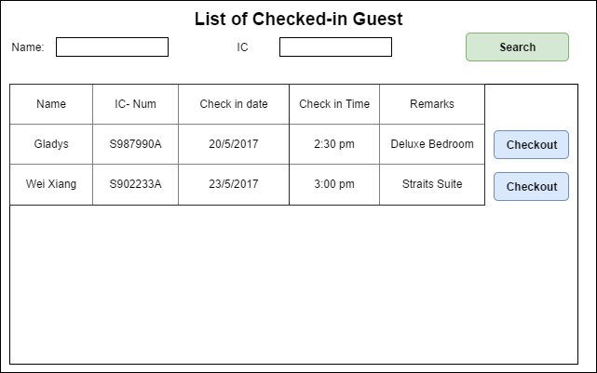

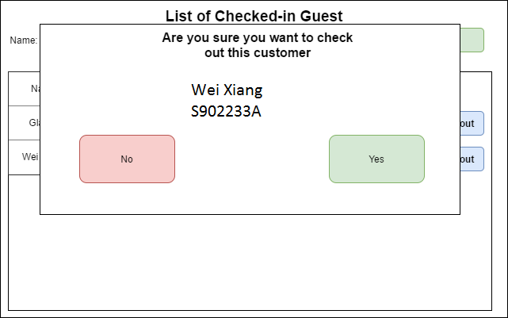

*(Figure 7b: Checking out)*

Receptionist will be managing the checkout function by selecting the checking out option from the homepage/menu will display the checkout page. It displays the list of checked-in users and receptionists are able to perform a search on the customer’s name and Identification number to search the customers. By searching the specific user, selecting check-out and confirming it, will check out the customer.

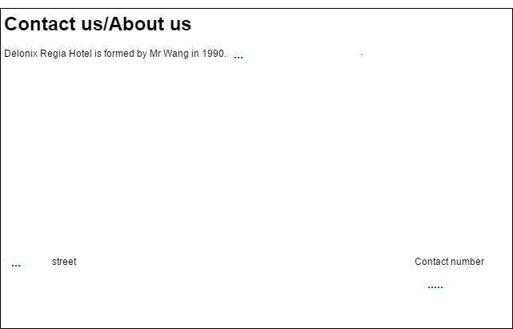*(Figure 8: About Us / Contact Us)*

The About Us/Contact Us can be accessed by selecting the “About Us/Contact Us” from the homepage/menu will display the About Us/Contact Us page. The page will display about the hotel’s information and the contact number and also the address of the hotel.

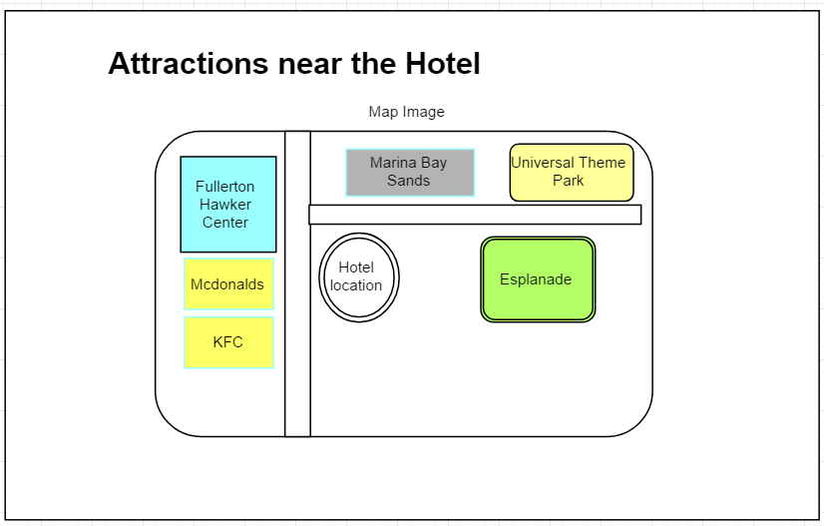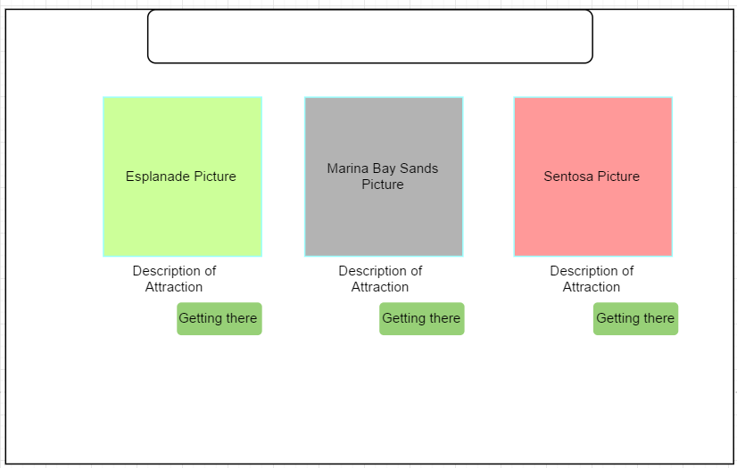

*(Figure 9: Viewing Attractions)*

Customers would be able to view the attractions near the hotel via the map or look at other distinct popular tourist attractions and how to get there in the same page. The how to get there page will show details on how to get to the attraction, either by public transport or a taxi service which the hotel may provide for the customer. They can access the page via the Attractions button in the home page.

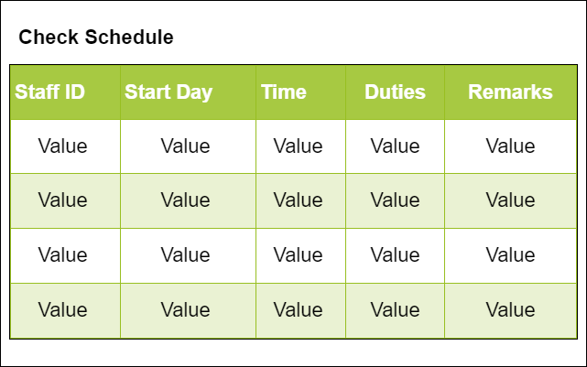

*(Figure 10a: View Schedule - Housekeeping / Staff)*

The housekeeping and other staff will be able to view their duties by selecting the “check schedule” button. The page will display the staff ID, start day, time, duties and remarks.

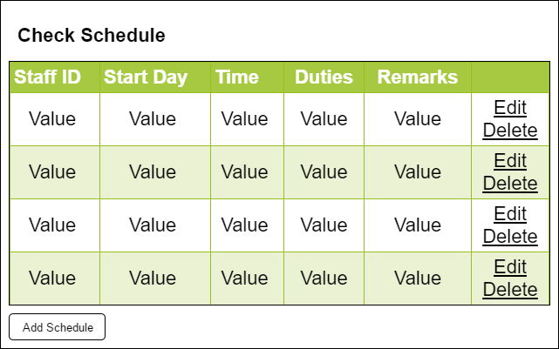

*(Figure 10b: Manage Schedule (Admin) - Housekeeping / Staff)*

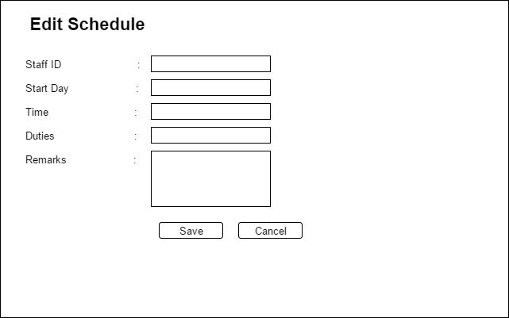

*(Figure 10c: Manage Schedule (Admin) - Housekeeping / Staff)*

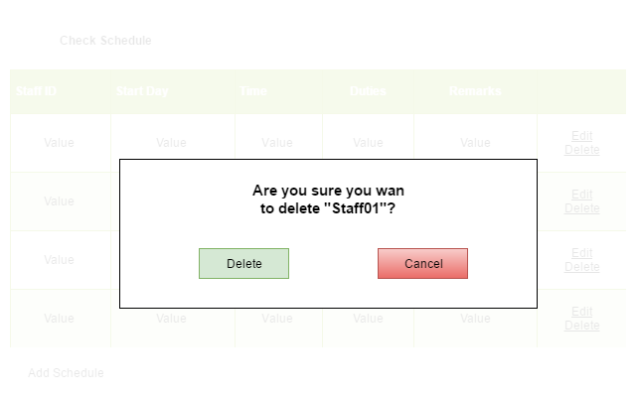

*(Figure 10d: Manage Schedule (Admin) - Housekeeping / Staff)*

For the manage schedule, only the admin can accessed to it. Basically the admin will have an additional button such as “edit”, “delete” and “add schedule” under the check schedule page. Base on what the admin click on, the admin will be able to delete a particular row, edit a particular row and add a new row for new schedule.

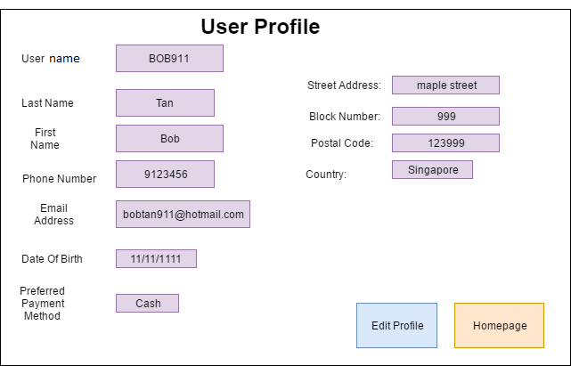*(Figure 11a: View User Profile)*

View User Profile can be accessed by selecting the “Profile” option in the home/menu page.Users are able to view username, last name, first name, phone number, email address, date of birth and preferred payment method. The user is also able to view his mailing address there which includes street address, block number, postal code and country.There are 2 options in the view user profile page. One option would allow user to edit profile, another option would allow user to return to the homepage.

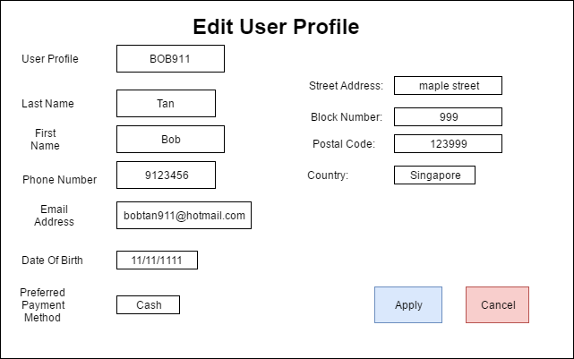

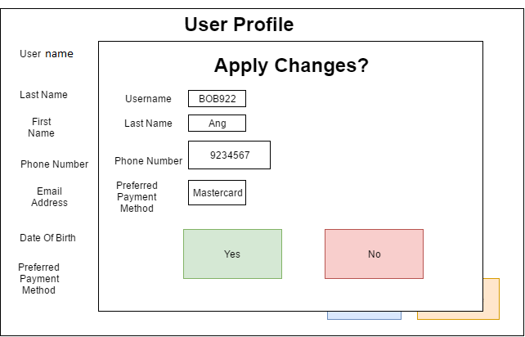

*(Figure 11b: Edit User Profile)*

Edit User Profile can be accessed by selecting the “Edit Profile” option in the View user profile page.Users are able to change their username, last name, first name, phone number, email address, date of birth and preferred payment method.Users are able to change his mailing address there which includes street address, block number, postal code and country. A confirmation will appear to show if the user would like to confirm the changes.

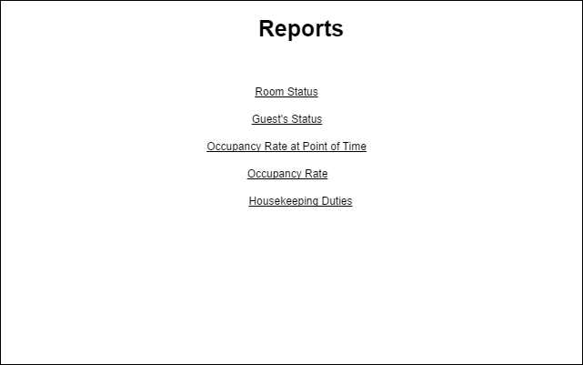

*(Figure 12a: Report - Selection of Rooms)*

Admins, Receptionist and Housekeeping staff will be able to view the reports done and have access to them. They will be able to select the types of reports they would like to view. Admins have access to all of the reports while receptionist will have access to room status, guests status and occupancy rate at point of time. Housekeeping staff will have access to Room status and Housekeeping Duties reports.

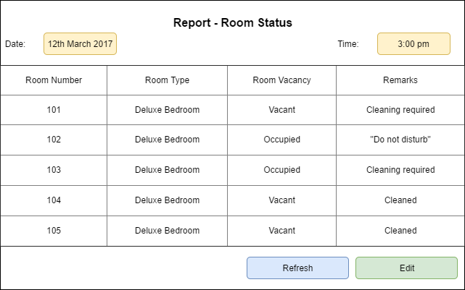

*(Figure 12b: Report - Room Status)*

Admins, Receptionist and Housekeeping staff will be able to view the Room status of all the rooms. They are able to change the date and time to view informations of room at those times. They are all also able to edit the remarks and the vacancy of the rooms.

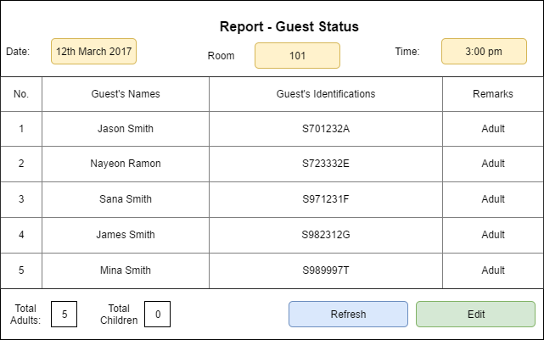

*(Figure 12c: Report - Guest Status)*

Admins and Receptionist will have access to the guests status. They are required to select the Date, Room number and also time to display the reports of the guest status in the particular room. They are able to also perform actions like editing the information below.

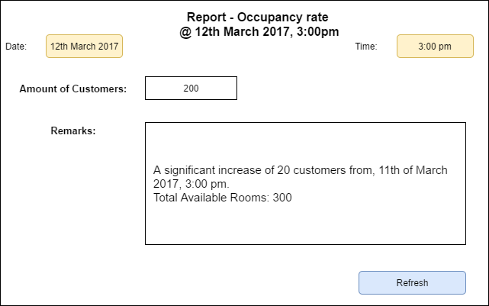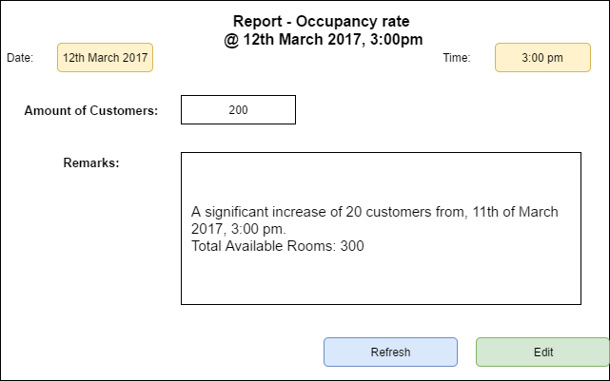

*(Figure 12d: Report - Occupancy rate at point of time)*

Occupancy rate at point of time can be viewed by admins and receptionists by selecting the specific date and time. Receptionist are only able to view this. This will display the amount of customers and the remarks of it. Admins are the only ones able to edit the remarks.

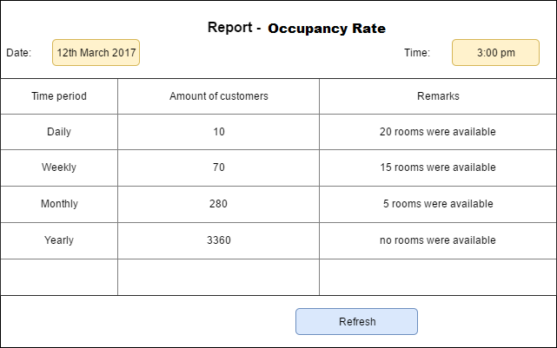*(Figure 12e: Report - Occupancy rate)*

Admins and Receptionist will have access to the Occupancy rate. They will be shown the daily, weekly, monthly and yearly of how much customers they are getting and how many rooms were available.

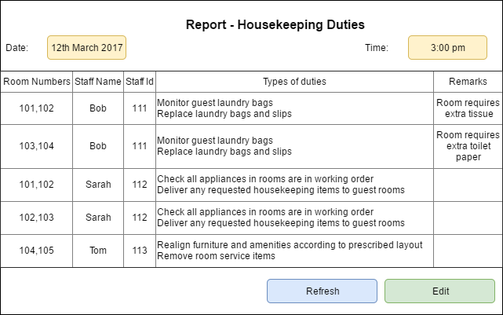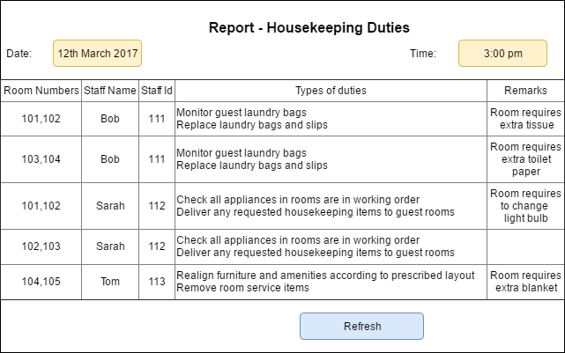*(Figure 12f: Report - Housekeeping Duties)*

Housekeeping Duties can be viewed by admins, housekeeping staff and by selecting the specific date and time. Housekeeping staff can only view this report. This will display the amount of customers and the remarks of it. Admins are the only ones able to edit housekeeping duties.

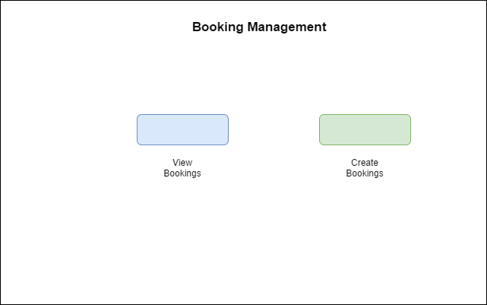

*(Figure 13a: Booking Management)*

Booking Management can be managed by the Admins and the receptionist. There are 2 selection which can be done either to view the bookings or to create bookings which will redirect to the booking a room.

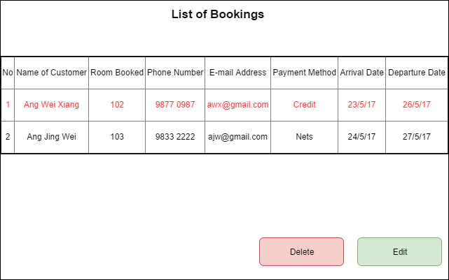

*(Figure 13b: List of Bookings)*

The list of bookings displays the list of bookings done by the customers or customers. It provides information which can be selected to highlight it and perform other tasks such as Delete and Edit.

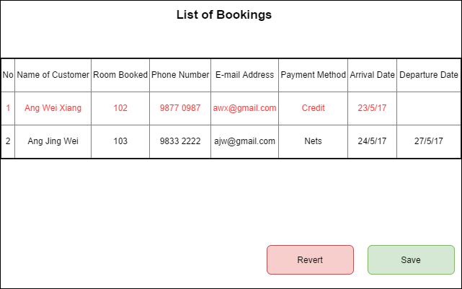

*(Figure 13c: Edit Bookings)*

The edit bookings will allow the admin and receptionist to edit the changes about the booking information, example a customer would like to request to change the arrival date and etc.

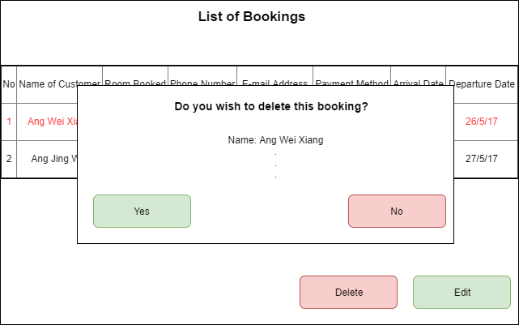

*(Figure 13d: Delete Bookings)*

Delete Bookings, which can be done by the receptionist and admin, will be done by selecting the row and deleting it. It will remove the entry from the database. It will require a double confirm request before permanently removing the booking information.

## **2.7** **Interface with Other Systems**

*[Describe any requirements to interface with other system, either new or existing. List any specification for interfacing and the required data format for communication between the systems. Include any security considerations for such data transfer. ]*

* Payment module should be linked to the NETS terminal for credit card payments, such as Mastercard or VISA.
* Opening only port 80 of the server to secure the data that is being transferred between the clients and the system.

## **2.8** **Assumptions**

*[Record any assumption made or implied regarding the requirements you have gathered for the system.]*

* Assume that the rooms are identified by a room number, level order so 21-4 would mean room 21, 4th floor for example.
* Assume that the hotel has deluxe, straits, family, presidential suites.
* Assume that all customers have an identification number no matter their nationality.
* Assume that the hotel only accepts 3 payment methods, which are Cash, Visa and Mastercard.
* Assume that there is an option for late checkout in the system.
* Assuming that Mr Wang’s hotel already has a server to host websites.

# 

# 

# **3** **OPERATIONAL AND QUALITY REQUIREMENTS**

## **3.1** **Operating Environment**

*[Describe the actual operating environment that the system will be deployed.]*

## The system will be deployed on the main desktops in the receptionist staff area. The Receptionist computers are running Pentium 4 Pc running on Windows Xp, 1GB ram and 160GB hard disk connected to internet via broadband.

**Hardware**

The system will be deployed on the main desktops in the receptionist staff area. The Receptionist computers are running Intel Xeon processor running on Windows 10, 8GB ram and 1TB hard disk connected to internet via broadband.

**Software**

The website can run on any browsers where the data being stored in the Google Cloud Storage where the receptionist are able to use Microsoft Project to and Microsoft Office to check out their schedules and write reports.

## **3.2** **Development Constraints**

*[List any constraints that are given during the development of the system. (e.g. schedule, platform, etc.). ]*

* Different version of programs are used to develop the website.
* Different methods of implementing the codes.
* Compilation issue could be a problem within the team.
* Different implementation times due to having different schedules.
* Lack of experience in the programs we will be using.
* Lack of time allocated for the development process.
* Too much time spent on debugging the errors.
* Software Bugs could occur occasionally causing time wastage.
* Lack of testing causing occasional bugs in the website
* Lack of Planning on phases such as Database Design, User Interface and etc.

## **3.3** **Performance**

*[List the acceptable system response time for each function during time of operations; on the average and during peak hours.]*

System response time

* Check into room, 2 seconds during off hours and 4 seconds during peak hours
* Check out for room, 2 second during off hours and 4 seconds during peak hours
* Booking for room, 1 seconds during off hours and 3 seconds during peak hours
* Check availability of rooms, 1 seconds during off hours and 2 seconds during peak hours
* Report for room status, 1 seconds during off hours and 2 seconds during peak hours
* Report on guest information, 1 seconds during off hours and 2 seconds during peak hours
* Report on occupancy rate, 2 seconds during off hours and 4 seconds during peak hours
* Report of housekeeping information, 1 second during off hours and 2 seconds during peak hours
* Converting reports to excel, 4 seconds during off hours and 7 seconds during peak hours
* Checking duties, 1 seconds during off hours and 3 seconds during peak hours.
* Creating new account (admin function), 3 seconds during off hours and 5 seconds during peak hours
* Check availability of facilities, 1 seconds during off hours and 3 seconds during peak hours
* Book facilities, 2 seconds during off hours and 4 seconds during peak hours

## **3.4** **Availability**

*[State the system availability requirements e.g. the system is required to run 24 by 7 or the system is required to run during normal working hours (8am to 6pm) from Monday to Friday. State also the acceptable downtime for maintenance and data backup. For example, 2 hours per week. ]*

The system will be running 24 hrs a day and it will have maintenance for 3 hrs every Wednesday fortnight from 1am to 4am. Data Backup will be done on the first sunday of every month during the non-peak hours which is from 2-3 AM. The records will be kept for 5 years before being safely discarded.

The acceptable downtime would be around 5 - 10 minutes a week.

## 

## 

## **3.5** **Security and Access Control Requirements**

*[Specify the user groups that can have access to the respective functions and the user locations (if this is a distributed system). Specify user authority to facilitate control over system access and data access. Identify any log required for audit purpose. List any other security requirements such as data encryption or authentication. ]*

* The reception staff at the front counter would have access to parts of the reporting module and full access to the room availability and booking module.
* Management users would have access to all the 3 modules.
* Admin users such as Mr wang would have access to all 3 modules,user accounts and the creation module.
* Housekeeping staff will only have access to view staff schedules.
* Customers will only have access to their own accounts.
* All the passwords for both staffID and UserID have data encryptions where all passwords are being Hashed.
* All payment modules or payment checkout process have data encrypted.

# **4** **SPECIAL REQUIREMENTS**

*[Any other requirements that are not included in the above headings, like data archival, etc.]*

None

**5** **REFERENCES**

*[List any books or web site that you have used when preparing this requirement specification.]*

http://www.best-job-interview.com/housekeeping-job-description.html